Project Design Phase-II
Data Flow Diagram & User Stories

Date | 30.09.2026
Team ID | SWTID-2026-4568
Project Name | AI FAQ Assistant API
Maximum Marks | 4 Marks

Data Flow Diagrams:
A Data Flow Diagram (DFD) is a traditional visual representation of the information flows within a system. A neat and clear DFD can depict the right amount of the system requirement graphically. It shows how data enters and leaves the system, what changes the information, and where data is stored.
Example: DFD Level 0 (Industry Standard)
Example: (Simplified)
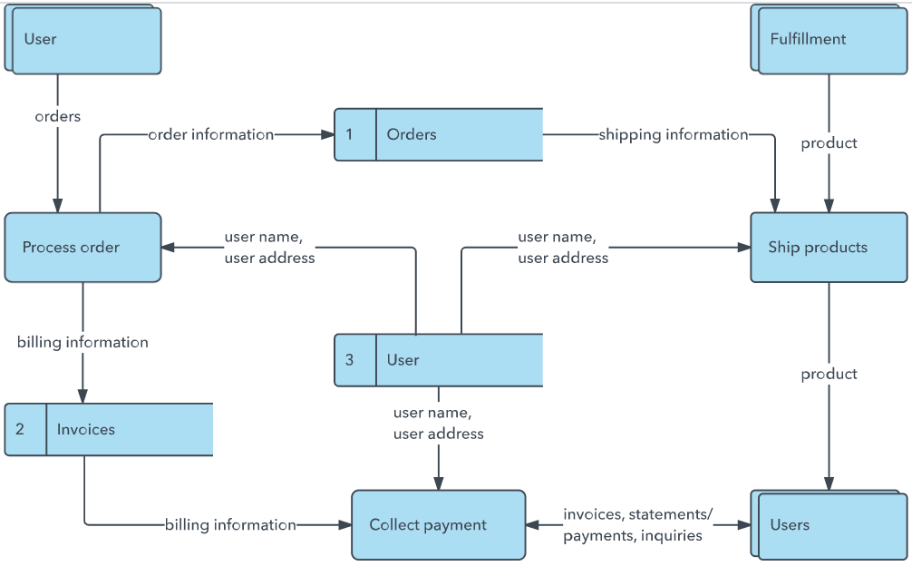


User Stories
Use the below template to list all the user stories for the product.
User Type | Functional Requirement (Epic) | User Story Number | User Story / Task | Acceptance criteria | Priority | Release
User | Ask FAQ | USN-1 | As a user, I can enter a question and receive an answer from the AI FAQ Assistant. | The system displays a relevant answer to the submitted question. | High | Sprint-1
 |  | USN-2 | As a user, I can view suggested frequently asked questions. | The system displays a list of FAQs that I can select. | High | Sprint-1
 |  | USN-3 | As a user, I can ask a question that is not in the suggested FAQs. | The system accepts the question and provides an answer or indicates when it cannot answer. | Low | Sprint-2
 |  | USN-4 | As a user, I can receive a clear response to my question. | The response is displayed in a readable format. | Medium | Sprint-1
 | API Access | USN-5 | As a client application, I can send a question to the AI FAQ Assistant API. | The API accepts a valid request and returns a response. | High | Sprint-1
 | Response |  | As a user, I can see an appropriate message when the API cannot process my question. | The system displays an understandable error or fallback message.

